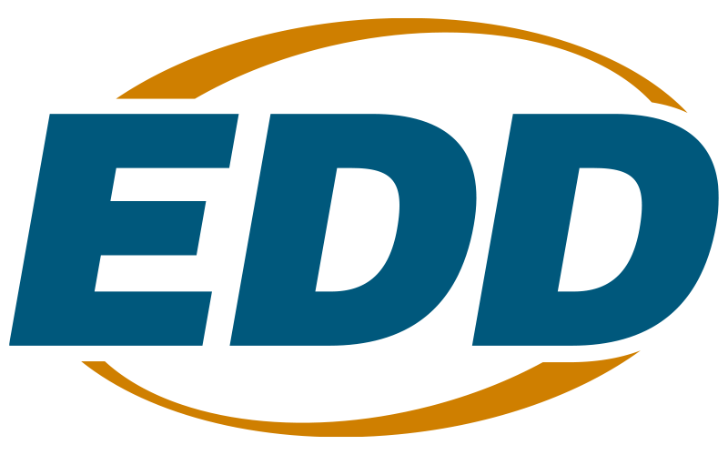

# Campesino de California Outreach Grant – Radio Media Program

# Solicitation for Proposals Program Year 2025-26

# Questions and Answers

1. **The last bullet point on page 22 of the SFP reads "Explain how these outreach methods will ensure equity goals are met?" Are these equity goals established by the EDD?**

That bullet refers to equity goals set by the applicant. Each organization will set its own goals for what percentage of the target population it will reach, and this section of the Project Narrative requires the applicant to identify their goals and explain how they will meet them.

2. **Are organizations required to establish a contract with a radio station before applying, or can they produce a podcast and distribute it on various social media platforms, such as YouTube? Is it mandatory for it to be broadcast on a radio station?**

It is mandatory for the show to be broadcast on the radio. The awardee must be able to procure and sign a contract with the appropriate broadcasting companies and repeater stations. In addition to the radio talk show, awardees must create complementary media posts on their website and use social media outlets to publicize the radio talk show videos.

3. **What are some common reasons an organization might get disqualified?**

The three most common reasons for an application to be disqualified are as follows:

1. Missing or incomplete Commitment Letters
2. No leverage fund requirement exists for the CCOG-RM solicitation; therefore, Commitment Letters are not required unless the applicant leverages resources. If so, applicants should provide a letter to verify the dollar amount and the source of contributions from each entity that pledges cash or in-kind resources to the project. Also, the leveraged resources stated in the Commitment Letters must match the leveraged funds on the Cover Signature Page submitted in the application.
3. No valid System of Award Management (SAM) account registration
4. Applicants must register with the SAM to apply for and receive funding for this initiative. Registration with the SAM must be reviewed and updated every 12 months to remain current, accurate, and complete in the SAM database. A recipient must maintain active registration with current information during which it has an application under consideration or an active state or federal award, including state and federal funding distributed through the EDD.
5. Missing or incomplete exhibits
6. Before applying, please ensure that all required exhibits have been completed and are included in the submission.

4. **Do the recommended exhibit file names have to be followed exactly for a proposal submission to be accepted?**

No, proposal submissions will be accepted regardless of whether the organization follows the recommended file naming conventions. It is highly recommended that organizations follow the conventions to ensure each exhibit is included in the submission and to not exceed our filing system’s character limit.

5. **What is the dollar amount that constitutes a large purchase for which an Exhibit G must be completed?**

Large purchases are items over $10,000.00 and must be detailed on Exhibit G the Supplemental Budget.