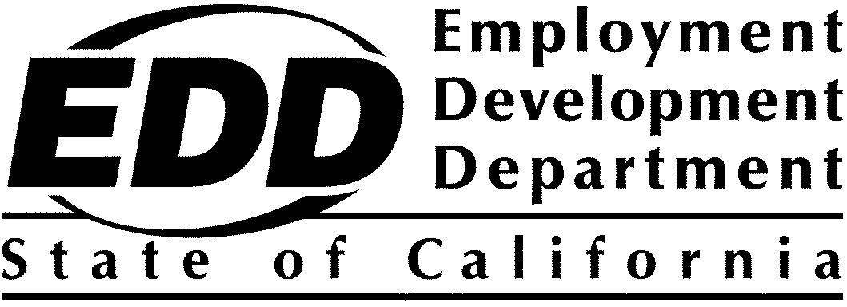

# Disability Equity, Access, and Inclusion Technical

# Assistance and Developmental Evaluation PY 2024-25

# Award List and Project Summaries

On December 11, 2024, $1,499,883 of *Workforce Innovation and Opportunity Act* (WIOA) Title IV Vocational Rehabilitation (VR) funds were awarded to the Loyola Marymount University under the Disability Access, Equity, and Inclusion (DAEI) Technical Assistance (TA) and Developmental Evaluation (DE) Program for Program Year (PY) 2024-25 Solicitation for Proposals. Awardee project list and project summary is listed below. Funding decisions are final.

## Award List

|  |  |  |
| --- | --- | --- |
| **Applicant Name** | **County** | **Award** |
| Loyola Marymount University | Los Angeles | $1,499,883 |

|  |
| --- |
| Project Summaries |

|  |  |
| --- | --- |
| **Applicant** | **Loyola Marymount University (LMU)**  1 LMU Drive  Los Angeles, CA 90045-2659 |
| **Contact** | Carla Cortez  1-310-338-1971  [Carla.Cortez@lmu.edu](mailto:Carla.Cortez@lmu.edu) |
| **Award** | $1,499,883 |
| **Industry Focus** | LMU will study the demographics, needs and barriers to success among People with Disabilities (PWD), evaluate the effectiveness of existing services, provide Technical Assistance (TA), training, support, make recommendations for systemic improvements, identify and share best practices, gaps and challenges, and apply time-tested, innovative strategies to improve outcomes for PWD. |
| **Key Partners** | * Former U.S. Representative, the Honorable Tony Coelho * EQUUS Workforce Solutions * South Bay Workforce Investment Board (SBWIB) * Imperial County Workforce Development Board * Commission on Accreditation of Rehabilitation Facilities (CARF) International * TAD Grants |
| **Project Description** | **Technical Assistance and Developmental Evaluation Plan**  LMU will study the demographics, needs and barriers to success among People with Disabilities (PWD), evaluate the effectiveness of existing services, provide Technical Assistance (TA), training, support, make recommendations for systemic improvements, identify and share best practices, gaps and challenges, and apply time-tested, innovative strategies to improve outcomes for PWD.  **Service Model**  LMU will prioritize outreach and recruitment of PWD reflective of the regional community, including persons representing a wide range of disabilities who are Black/African American or Latinx. Service model components include Interdisciplinary Teams, Training and Professional Development, Mentorship Programs, Disability Justice Summit (DJS), and Digital Platforms.  **Goal Measurement Methodology**  Communities of Practice will convene regularly to discuss progress toward reaching established goals, challenges, programmatic adjustments, corrective actions, and continuous quality insurance strategies, ensuring that lessons learned are effectively adapted to meet the specific needs of each pilot site. Documentation will include meeting summaries, action plans, and participant feedback, creating a comprehensive record that informs ongoing improvements. To establish a clear baseline, initial assessments of participant demographics, service utilization, and employment outcomes will be conducted at the start of the project. This baseline data will serve as a reference point for measuring progress and evaluating the impact of implemented strategies. Targeted outreach measures will be designed and deployed to ensure equal access for PWD from underrepresented communities. |
| **Expected Outcomes** | Proposed outcomes for this project reflect both immediate and lasting impacts, ensuring meaningful change in the employment landscape for PWD in California. Short term outcomes include successful project design, development, and implementation of cross system collaboration in each region that will lead to enhanced access, improved employment outcomes for PWD, and systems that promote inclusivity and equity within the workforce system that can be sustained beyond the project’s duration. |