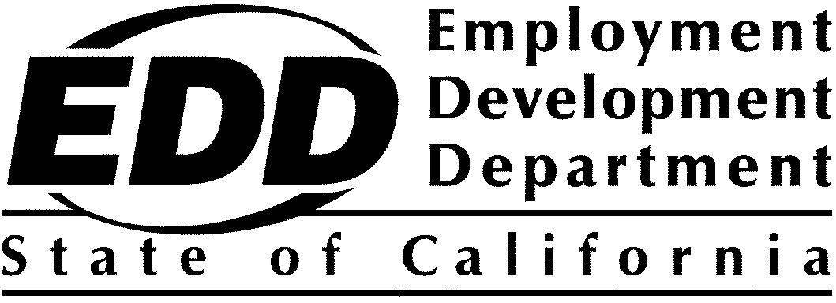

# Displaced oil and gas workers fund

# Evaluation and Technical Assistance Program Year 2023-24 Award List and Project Summaries

## On October 22, 2024, $999,764.76 from the State of California's general fund was awarded to one organization under the Displaced Oil and Gas Workers Fund (DOGWF) Program Evaluation and Technical Assistance (ETA) for Program Year 2023-24 (PY 23-24) Solicitation for Proposals. The awardee and project summary are listed below. Funding decisions are final.

## Award List

|  |  |  |
| --- | --- | --- |
| **Applicant Name** | **County** | **Award** |
| Corporation for a Skilled Workforce | N/A | $999,764.76 |

|  |
| --- |
| Project Summaries |

|  |  |
| --- | --- |
| **APPLICANT** | **Corporation for a Skilled Workforce**  10246 Crouse Road #17, PO Box 17  Hartland, MI 48353 |
| **CONTACT** | Amy Wallace  1-734-769-2900  [awallace@skilledwork.org](mailto:Erica.Bouris@rescue.org) |
| **AWARD** | $999,764.76 |
| **COUNTIES TO BE SERVED** | N/A |
|  |  |
| **TARGETED POPULATION EXPERTISE** | Corporation for a Skilled Workforce (CSW) has experience providing comprehensive program improvement services across federal, state, and local levels. They have delivered impactful solutions in diverse industries, including oil and gas technical assistance (TA) in Alaska and occupational analysis in Texas. Furthermore, CSW has a proven track record supporting large-scale initiatives like the American Recovery and Reinvestment Act program, Workforce Benchmarking Network, and the American Apprenticeship Initiative, demonstrating their ability to deliver effective TA across a wide range of contexts. |
| **KEY PARTNERS**  **PROJECT DESCRIPTION**  **TECHNICAL ASSISTANCE PLAN FOR TARGETED POPULATIONS TO BE SERVED** | CSW has a two-decade history of providing workforce development services to the State of California, working with local workforce boards, evaluating America's Job Centers, and providing TA to sector partnerships. CSW's work with the state and local workforce boards in Santa Barbara, Los Angeles, San Diego, San Francisco, and others has involved developing industry sector analyses, conducting business and job seeker surveys and focus groups, and facilitating strategic planning and service delivery plans with local board members, staff, and leadership. CSW has also conducted numerous evaluations and provided technical support to the California Workforce Development Board.  CSW will provide ongoing TA to DOGWF program grantees, focused on fostering equitable transitions to new employment with quality jobs and career pathways for the target populations, to ensure that all dislocated workers are offered opportunities to transition to new jobs with family-sustaining wages.  The proposed TA approach will build the capacity of the DOGWF grantees to develop the tools, systems, and strategies needed to assist highly skilled workers in making equitable transitions to new quality jobs and career pathways:   * Communities of Practice (CoPs) – DOGWF CoPs and other convenings will work to create a dynamic, collaborative community that empowers DOGWF grantees to excel. * Capacity-Building & Coaching – Working with staff and partners to enhance the ability to improve programs and worker outcomes, implement new tools and services, and contextualize best practices integration into program development. * Convenings – Host annual in-person convenings to provide face-to-face networking opportunities and collaborative workshops, deepening relationships among grantees. * Developmental evaluation and final report – incorporate grantee, worker, and employer perspectives, document pivot points, and identify best practices for success. * Skills Transferability Analysis – Conduct a comprehensive transferable skills analysis to assist program grantees in identifying existing skills, skill matches, and any necessary skill development gaps. * Successful Skills Transfers – Support grantees in translating their oil and gas industry skillsets to new occupations in emerging clean energy sectors and other sectors and identify training and credentialing programs that lead to successful re-employment, leveraging workers' existing skills. * Successful Re-employment Strategies – Identifying successful training methodologies and programs leading to re-employment. * Participant Recruitment & Engagement – Identifying and lifting practical evidence-based and best practices for attracting and retaining workers in transition programs. |
| **PROPOSED**  **OUTCOME** | Outcomes for the project include the following:   * Helping oil and gas workers directly impacted in program grantee regions transition to good jobs. * Assisting program grantees by developing the tools, systems, and strategies to help oil and gas workers move into new quality jobs. * Assisting program grantees in developing the knowledge and systems infrastructure to do this work in other industries that are transitioning now or in the future. * Document this process to learn from the project and share it with stakeholders. |