

1400 10th St
Sacramento, CA 95814
OFFICE 916-323-7646

California Volunteers Helps You Stay Connected and
Find Volunteer Opportunities
California Volunteers, Office of the Governor connects Californians with meaningful volunteer opportunities in their communities. Whether you're interested in supporting your local community, participating in statewide service initiatives or finding volunteer opportunities that match your interests and availability, the California Volunteers website offers a variety of resources to help you get started.
Volunteers can join the #CaliforniansForAll network to receive updates on volunteer opportunities, events and ways to serve across the state. When you're ready to volunteer, you can also search and apply for opportunities on the California Volunteers website using the volunteer search, powered by Idealist.
This guide will walk you through the two simple steps to begin volunteering through California Volunteers:
- Join #CaliforniansForAll to stay informed about volunteer opportunities, community events and service initiatives across California.
- Search for and apply to volunteer opportunities on the California Volunteers website using the volunteer search, powered by Idealist, where you can browse opportunities by location, cause, skills, and more.

Step 1: Join #CaliforniansForAll
Joining #CaliforniansForAll is a great way to stay informed about volunteer opportunities, community events and service initiatives happening throughout California. By signing up, you'll receive updates from California Volunteers about ways to get involved and make a difference in your community.
Instructions
- Open your web browser and visit the California Volunteers website: California Volunteers | California Volunteers

- From the top navigation menu, select ‘Volunteer,’ then click ‘Join #CaliforniansForAll’ from the drop-down menu.
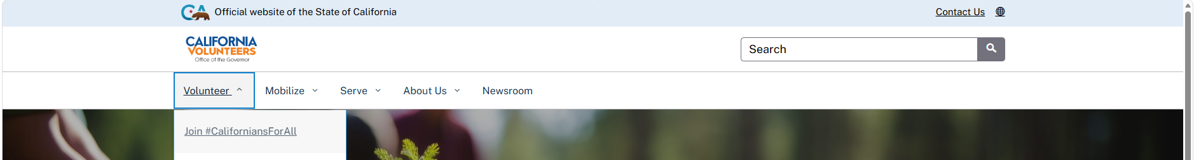

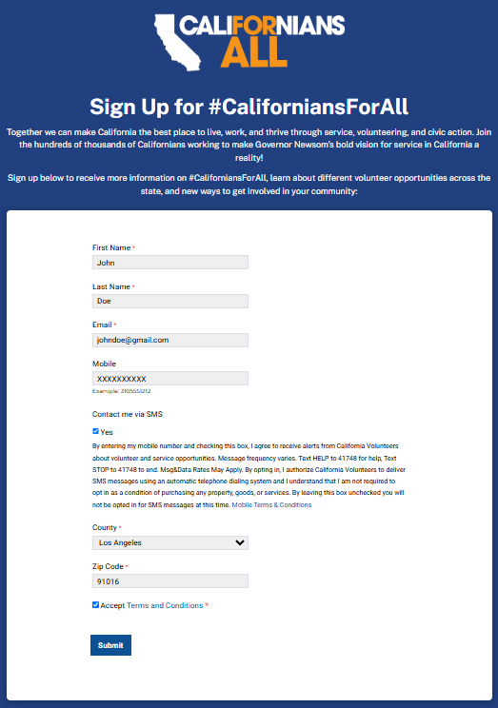
- Complete the #CaliforniansForAll sign-up form by providing your:
  - First and last name
  - Email address
  - Mobile phone number (optional for SMS updates)
  - County
  - ZIP code

- Select ‘Submit’ to complete your registration.
After submitting the form, you'll begin receiving updates from California Volunteers about volunteer opportunities, community events and other ways to serve throughout California. You can then move to Step 2 to search for and apply to volunteer opportunities matching your interests.

Step 2: Search for Volunteer Opportunities
California Volunteers' ‘Search’ feature connects you to thousands of volunteer opportunities across California through Idealist. You can search for opportunities based on your location, interests, skills or the causes you care about most, then apply directly to organizations that are recruiting volunteers.
Instructions
- Open your web browser and visit the California Volunteers website: California Volunteers | California Volunteers

- From the top navigation menu, select ‘Volunteer,’ then click ‘Search’ from the drop-down menu.


- After clicking ‘Search,’ you will be redirected to the California Volunteers volunteer search, powered by Idealist.

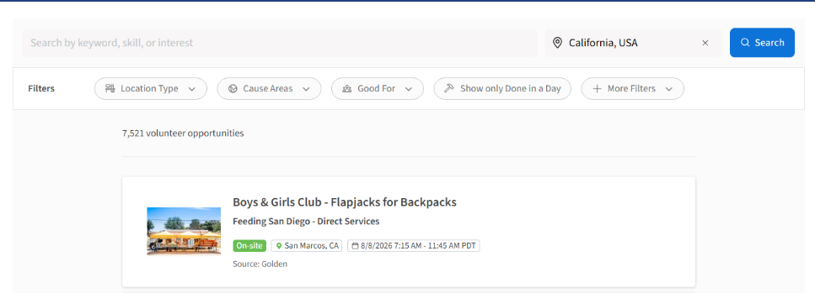
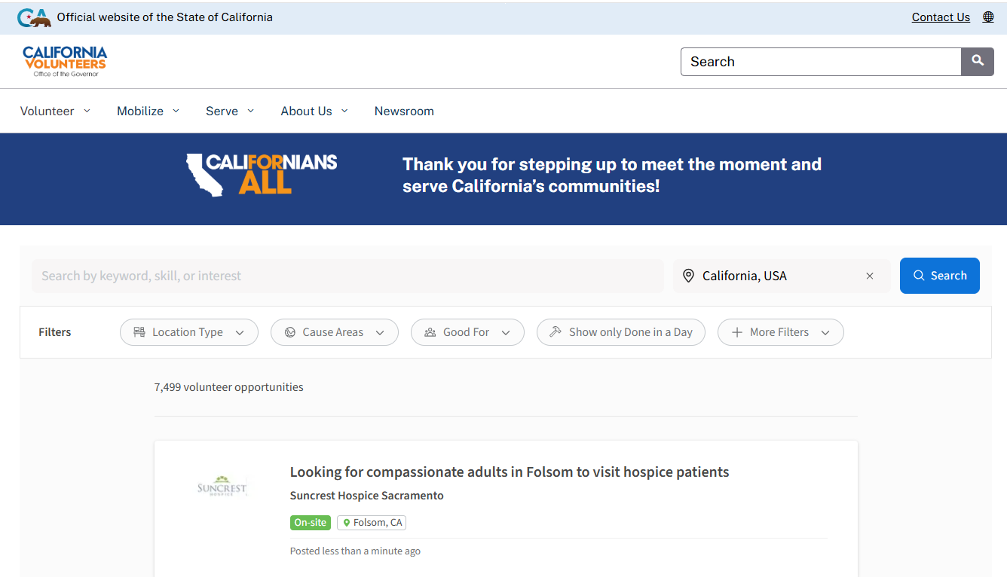
- Here, you can begin to search for volunteer opportunities by entering one or more of the following:
  - Keyword, skill or interest (e.g., tutoring, food bank, environment)
  - Location (city, ZIP code or county)
  - Any additional search criteria that matches your interests
  - Select ‘Search’ to view available volunteer opportunities.

- To refine your search results, use the available filters including but not limited to:
  - Cause area
  - Skills
  - Location type (On-site, Hybrid or Remote)
  - Distance from your location
  - Date posted

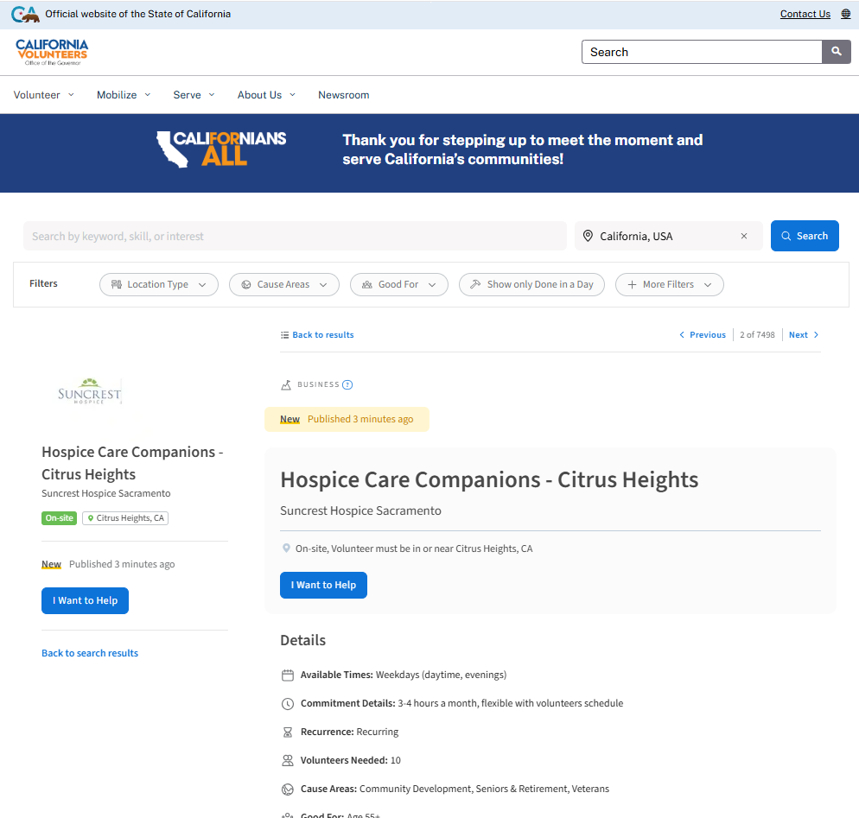
- Select a volunteer opportunity to view additional details including:
  - Organization name
  - Opportunity description
  - Location
  - Volunteer responsibilities
  - Time commitment
  - Application instructions

- When you're ready, select
‘I Want to Help’ (or follow the organization's application instructions) to begin the application process. Depending on the organization, you may apply directly through Idealist, by email or through the organization's website.

