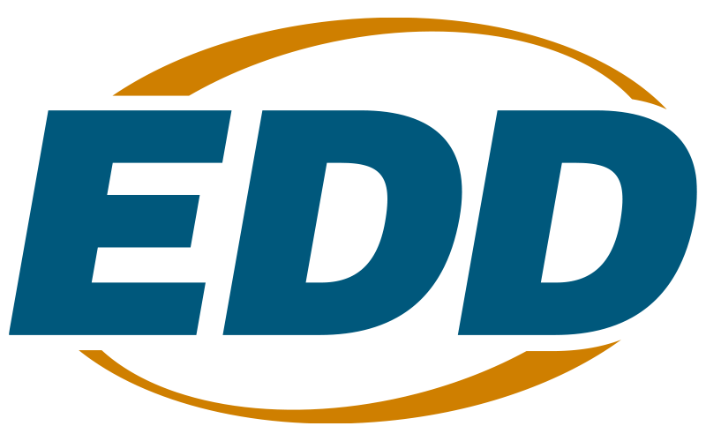 | Directive  Date: November 14, 2022 Number: WSD22-07 | 

Debt Collection

Executive Summary

This policy provides the guidance and establishes the procedures regarding debt collection associated with audit findings and allegations of fraud, waste and abuse pertaining to federal Workforce Innovation and Opportunity Act (WIOA) funds. This policy applies to all subrecipients expending WIOA funds, and is effective on the date of issuance.

This policy contains some state-imposed requirements. All state-imposed requirements are indicated by bold, italic type.

This Directive finalizes Workforce Services Draft Directive Debt Collection (WSDD-236), issued for comment on July 18, 2022. The Workforce Development Community submitted no comments during the draft comment period.

This policy supersedes Workforce Investment Act Directive Debt Collection (WIAD01-5), dated September 10, 2001. This Directive remains active until further notice.

References

- WIOA (Public Law 113-128) Section 184
- Title 20 Code of Federal Regulations (CFR) Part 600: Employment and Training Administration, Department of Labor Sections 683.410(a), 683.420(a)(1)(i) and 683.740

Background

The WIOA requires states to establish fiscal controls. In California, the Employment Development Department (EDD) is the administrative entity for federal WIOA funds. Among the required controls specified in Title 20 CFR Section 683.420(a)(1)(i) is a process for debt collection.

Policy and Procedures

Definitions

Awarding Agency – means (1) with respect to a grant, the Department of Labor (DOL); and (2) with respect to a subgrant or contract, the entity that awarded the subgrant or contract.

Final Debt – the amount owed based on the awarding agency’s final determination if an appeal is not filed, or the decision issued in response to an appeal. Included in final debts are funds due from, but not limited to, incidents of fraud, malfeasance, misapplication of funds or other serious violations or illegal acts.

Final Determination – the awarding agency’s decision to allow or disallow questioned costs and resolve any nonmonetary findings.

Subrecipient – a non-federal entity that receives a subaward from a pass-through entity to carry out part of a federal program, but does not include an individual that is a beneficiary of such program. A subrecipient may also be a recipient of other federal awards directly from the federal awarding agency (Title 2 CFR Section 200.93). Local Workforce Development Boards (Local Board) are the subrecipients of WIOA funds and other federal grant awards. A Local Board may allocate funds to their subrecipients to carry out a part of the federal program.

This Directive references both the “awarding agency subrecipient” and “their subrecipients.” For the purposes of this Directive, subrecipients will be labeled as the following:

- The “awarding agency subrecipient” is the agency who is directly funded and in a subgrant with the EDD.
- And “their subrecipient” is the agency at the local level that receives funds from the awarding agency subrecipient to carry out a portion of the program.

Debt Collection Requirements

The EDD’s Compliance Review Office (CRO) is responsible for overseeing the audit resolution and debt collection over subrecipients of WIOA funding. At the local level, the awarding agency subrecipient is responsible for their subrecipient audit resolution and aggressive debt collection action. Each awarding agency subrecipient must establish, describe and maintain written debt collection procedures that include the following:

- A process for notifying their subrecipients of the establishment of the debt, their appeal rights, the date that the debt will be considered delinquent, the sanctions if the debt is not repaid (which may include, but are not limited to, debarment), and the interest rate charged, if any.

- The requirement that three debt collection letters be sent to their subrecipient at no less than 30 calendar day intervals.

- The establishment of an outstanding debt category in the awarding agency subrecipient’s accounts receivable system.

- The awarding agency subrecipient’s standards and specifications for terminating, compromising, and litigating debts.

- A process for maintaining a permanent record of all debt collection cases and their status.

To be relieved of liability for their subrecipient’s debt, the awarding agency subrecipient must submit a written request to the EDD’s CRO. The request is for the EDD to seek the US DOL’s agreement to forego collection action, pursuant to the provisions of Title 20 CFR Section 683.740.

Requests must include documentation and other demonstrations of facts showing compliance with WIOA Section 184(d) and Title 20 CFR Section 683.740. Mere statements of compliance and recitation of the criteria will not be acceptable. Examples of appropriate documentation include, but are not limited to, proof that debt collection letters were sent (e.g., returned certified mail receipts), litigation was conducted, and withholding of funds was attempted. Without the prior approval of both the CRO and the DOL, the awarding agency subrecipient will remain responsible for repayment of the entire debt. The request and supporting documentation must be submitted to the CRO through one of the following methods. However, email is the preferred method.

Email PACBCROIncidentReports@edd.ca.gov

Mail Employment Development Department
Compliance Review Office
Compliance Resolution Unit
PO Box 826880, MIC 22
Sacramento, CA 94280-0001

Unless other arrangements have been documented and approved by the CRO, the awarding agency subrecipient and (when appropriate) their subrecipient, must pay all their WIOA debts within 30 calendar days of the date on which the debt was established as final. If the awarding agency subrecipient is unable to make restitution in full, then an installment repayment agreement may be negotiated. Installment repayment agreements have a short duration ranging from 3 to 12 months, with a maximum of 36 months. The length of the installment repayment agreement will be negotiated based on the size of the debt and the awarding agency subrecipient’s ability to pay. The CRO must approve all installment repayment agreements.

The CRO will do the following:

- Instruct the EDD’s Fiscal Program Division (FPD) to issue an invoice with payment due date and the interest charge, if any, to the awarding agency subrecipient once a final debt is established.

- Notify FPD to issue two additional invoices to the awarding agency subrecipient at 30 calendar day intervals, when payment has not been received or a satisfactory alternative repayment plan has not been negotiated.

- Determine whether to use another method of collection if the debt is still outstanding after 90 calendar days. In making the determination, consideration will be given to the amount of the debt, the cost of further debt collection, the amount collected to date, and the probable success of pursuing further collection action.

- Notify the Chief Elected Official of each relevant unit of general local government (Local Boards), or the head of an organization (non-Local Boards), if the agreed upon payment is not received within the 90 calendar days after the date of the third invoice. For Local Boards, when multiple units of general local government are designated as the Local Area, the liability of the individual jurisdictions must be specified in a written agreement between the Chief Elected Officials.

Debt Collection Remittance

All debt settlements resulting from fraud, malfeasance, misapplication of funds, or other serious violations or illegal acts must be made in cash from nonfederal sources. Debt settlement funds collected by an awarding agency subrecipient debts must be returned to the EDD immediately upon their receipt. A Payment Advice Form (Attachment 2), which details the program year, subgrant number, project name, and grant code associated with the debt settlement funds, must be remitted with a check or warrant made payable to the Employment Development Department to the EDD’s Fiscal Program Division (FPD):

Mail Employment Development Department
Fiscal Programs Division
ATTN: MIC 70, Administration and Grants Unit
PO Box 826217
Sacramento, CA 94230-6217

The FPD will inform and coordinate with the CRO when the payment is received and posted. Once the payment is posted, the CRO will notify the subrecipient. The awarding agency subrecipient must maintain records that document the actions taken with respect to debt collection, restoration, or other debt resolution activities and why the actions were taken to support their decisions.

When the debt is not a result of fraud, malfeasance, misapplication of funds or other serious violations or illegal acts, the cash repayment of the disallowance is a credit to the title and year to which it was originally charged. The credit reduces the expenditures of the period of the cost that was refunded. If the year of allocation is still open, awarding agency subrecipients may expend the funds within the cost limits. Cash payments received after the fund availability period must be remitted to the EDD.

Action

Bring this Directive to the attention of all affected staff and subrecipients.

Inquiries

If you have any questions, contact your assigned Regional Advisor.

/s/ JAVIER ROMERO, Deputy Director
Workforce Services Branch

Attachments:

- Instructions for Payment Advice Form (DOCX)
- Payment Advice Form (DOCX)
- Amendment Chronology (DOCX)
The EDD is an equal opportunity employer/program. Auxiliary aids and services
are available upon request to individuals with disabilities.

