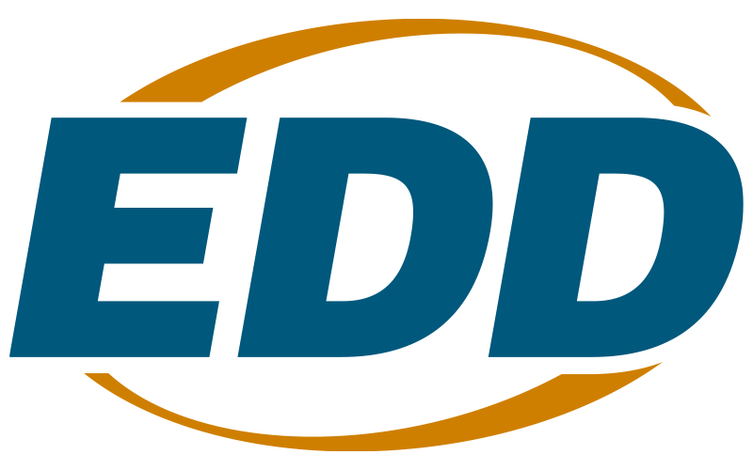

Deaf and Hard of Hearing Services

Solicitation for Proposals Program Year 2026-27

Questions and Answers

- Can applicants apply to provide services within the Sonoma and Solano County service areas?

Solano and Sonoma counties are within the San Francisco Bay Area, which is a priority region under this solicitation.

Further, the locations listed in the SFP are for consideration of priority only. If an applicant proposes serving a geographical area not listed, the applicant may still apply, but the proposal must clearly identify the deaf and hard of hearing population and the need for services in that area and demonstrate why those needs are not currently met. The EDD will review the request and determine the suitability and availability of space for co-location to determine if another area not listed can be approved. For more information on DHH program locations, please see page 6 of the SFP.

- Please clarify whether floor managers must approve interpreting hours.

As stated on page 9 of the SFP, “The grantee must provide services during normal office hours, excluding Saturdays, Sundays, and state holidays. Hours and days of service must be on a consistent schedule approved by the AJCC site manager. EDD must approve services beyond the approved hours before being provided.”

- Are room rentals for workshops provided to participants billable for this grant?

This solicitation aims to provide enhanced employment services for deaf and hard of hearing individuals by providing specialized counseling, interpretation services, job placement, and follow-up services, as well as specialized employment preparation services to assist them in becoming job ready. If an applicant plans to utilize rented space to facilitate workshops for program participants, their proposals should demonstrate how this cost supports their program to achieve the goals listed above.

For more information about allowable activities under this funding opportunity, please see pages 7 and 10-11 of the SFP.

- What type of pre-employment interpretation is covered in this grant? Interviews are clear, but what other types of services could be covered?

According to page 11 of the SFP, “DHH staff shall make job-readiness services available to eligible participants, including helping deaf and hard of hearing job seekers prepare resumes, applications, cover letters, and other related materials. Job preparation activities may also include interview preparation, such as mock interviews.”

Please refer to the SFP for more detailed information on allowable activities under this funding opportunity.

- Is there a preferred 12-point font? This SFP only shows 12-points with no style.

There is no required font style for this solicitation.

- If we serve multiple counties, should we submit a separate Performance Matrix for each, or can we list them all on one?

Applicants can include all counties in one Performance Matrix.

- If an applicant plans to bid for multiple areas, can a single proposal be submitted?

Yes, if an applicant proposes to serve more than one location, the proposal should outline all areas they wish to serve and the proposed service delivery model. We will accept only one proposal from each entity applying.

- Given that award announcements have historically occurred several months into the fiscal year, can you clarify the expected award announcement date listed in the SFP timeline?

The awards will be announced once the federal funds have been made available to the EDD. All dates after the final proposal submission deadline are approximate and may be adjusted as conditions dictate without an addendum to the SFP.

- Are public school districts eligible to apply for this grant?

Proposals will be accepted from public agencies or private non-profits. Individuals are not eligible to apply. Applicants must clearly demonstrate their ability to provide services to the targeted population.

- How can we receive the overall score from our previous grant proposal submissions from PY 2025-2026 and PY 2024-2025?

Applicants can request feedback on their previous grant applications, including their overall proposal scores, by emailing WSBSFP2@edd.ca.gov.

- Is the single audit based on gross profits or awards of over $1 million? Would the audit be conducted by EDD, or would the awarded company need to pay for one?

Single audit requirements are based on the entity’s total annual federal award expenditures. Audits are the responsibility of the awarded organization, and they must procure and pay for the audit themselves. More information regarding audit requirements can be located in 2 CFR 200.501.

