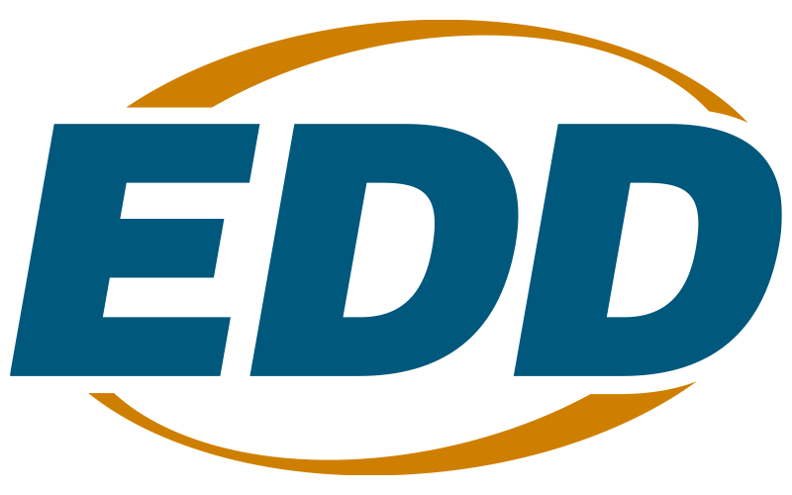

Regional Coordination Project

Solicitation for Proposals Program Year 2025-26

Questions and Answers

- Can an applicant with an indirect cost rate agreement of over 10% use the rate in their NICRA?

The 10 percent cap applies to all administrative costs, whether direct or indirect. An indirect cost rate of more than 10 percent can be charged if the dollar amount of the administrative portion of indirect costs plus any direct administrative costs remains under 10 percent. Please note that indirect cost rates are not calculated as a percentage of the total award but rather as a percentage of the base identified in an organization’s Negotiated Indirect Cost Rate Agreement (NICRA) or Cost Allocation Plan (CAP) or for those claiming the 15 percent De minimis rate, as a percentage of Modified Total Direct Costs (MTDC) as defined in 2 CFR 200.68.

- Are there any limitations on the type of funding that can be braided or leveraged for this
project?

Leveraged resources can come from a variety of sources. Leveraged resources can include non-cash contributions or third-party in-kind contributions for the purpose of sharing infrastructure costs. All leveraged resources will be subject to the reporting requirements contained in Workforce Services Directive Monthly and Quarterly Financial Reporting Requirements (WSD19-05) (December 4, 2019) and Title 2 Code of Federal Regulations (CFR) Part 200: Uniform Administrative Requirements, Cost Principles, and Audit Requirements for Federal Awards (Uniform Guidance), Section 200.306 Cost sharing or leveraging.

- Can applicants include non-community college, non-profit training partners that deliver
employer-validated, industry-recognized credentials in a proposal?

Education and training providers can serve as partners for this grant opportunity. However, only Local Workforce Development Areas (Local Areas) or Workforce Development Boards listed on the EDD LWDA Directory list are eligible to apply as the lead applicant.

- Is Exhibit K required, and if so, can EDD provide the Exhibit K: Performance Goals
Matrix template?

Yes, Exhibit K is required. EDD has provided the template to registered Informational Webinar attendees via email and will be uploading it to the Workforce Services Solicitations for Proposals website shortly. Applicants may also email WSBSFP1@edd.ca.gov for a copy of the Exhibit K template. EDD apologizes for any inconvenience this may have caused.

- Can EDD provide a clear definition of “industry-recognized credentials?”

The State Plan calls for the production of one million industry-recognized credentials over the next 10 years. In alignment with the vision articulated in the State Plan, the ideal characteristics of a quality industry-recognized credential includes the following:

- Accessible — Affordable and readily available at places and times convenient for working adults.
- Transparent — Clearly articulated costs and prerequisites; accurate picture of what skills, knowledge and abilities are benchmarked by a given credential, and the value it carries in the labor market.
- Stackable — One of multiple manageable chunks that add up to a more substantial credential and do not require starting over at each new step.
- Portable — Transferable between firms, regions, and educational institutions.
- Meaningful — Has value in the labor market.
- Connected — Links to a job or an educational pathway.

The goal is the workforce system will assess credentials based on the characteristics above.

For additional information and tools regarding industry-recognized credentials, please reference Workforce Services Directive WIOA Performance Indicators Policy and Guidance (WSD24-07).

- For the program section, can organizations also serve incumbent workers? Is that a population applicants can focus on, or is it not allowed under this grant?

Yes, a project can serve incumbent workers for this grant, as long as these participants meet WIOA eligibility requirements.

- Is the definition of “regions” for this grant based on Regional Planning Units or the Jobs
First Initiative?

Applicants will propose regional collaborations based on the labor market, existing partnerships, and other factors. Applicants are encouraged to consider the Jobs First regional boundaries, but they also have the flexibility to define a region that better reflects their labor market, partnerships, or strategic goals. Workforce boards may propose regional collaborations that cross or combine Jobs First Regions when doing so will improve service delivery and employment outcomes.

- Are for-profit entities allowable partners?

Yes, for-profit entities are allowable partners, but they cannot apply as the lead applicant.

- Will this solicitation also allow the inclusion of partnerships with K-12 Career Technical
Education programs?

Yes, K-12 Career Technical Education programs are allowable partners for this grant.

- Do existing MOUs qualify as Partnership Agreements, or do they need to be newly
developed?

Yes, existing MOUs can qualify as partnerships as long as the dates listed on the MOUs fall within the range of the period of performance for this initiative. The period of performance for projects funded under this SFP will be between 18 and 24 months, with an anticipated start date of June 1, 2026.

- Are Commitment Letters required for partners who will not be providing match funding?

Commitment Letters are not required for partners who will not be providing leveraged funding.

- If a Local Workforce Board is a nonprofit organization, are they still eligible to apply?

Only organizations listed on the Local Workforce Development Area Administrators list are eligible to apply for this funding opportunity.

- Do applicants need to provide a copy of their conflict of interest policy in their
application?

No, applicants do not need to provide a copy of their conflict of interest policies at this time.

- If an applicant has WIOA Title II and/or community colleges on their board who partner
with them, would this be considered a conflict of interest?

Additional information is necessary to determine if a conflict of interest exists. If selected for an award under the RCP Solicitation for Proposals, the organization will be required to disclose the potential conflict of interest in writing to the EDD.

- Are both Partnership Agreement Letters and Commitment Letters required for each partner agency and the lead agency?

Partnership Agreement Letters are required for each partner organization outlined in the proposal. Commitment Letters are required for any organization that is providing leveraged resources for the project, including the lead applicant. Commitment letters must verify the dollar amount and source of any cash or in-kind resources pledged for the project. If a partner organization is not providing leveraged resources, a Commitment Letter does not need to be submitted for that organization, but a Partnership Agreement Letter is still required.

- Can a Workforce Development Area apply as a lead on one application and participate as
a partner on another?

Yes, a Workforce Development Area can apply as a lead on one application and participate as a partner on another. However, if this applicant were to be selected for awards, they would need to discontinue the partnership with the other applicant. Entities are not permitted to receive funding twice from the same funding source.

- Do the required documents mentioned in the narrative questions in Exhibit A count
towards the 15-page limit? For example, some of the questions ask for an Organizational Chart or Logic Model.

The Organizational Chart (OrgChart) should be submitted as a separate exhibit, and does not count towards the 15-page limit for Exhibit A. Logic Models should also be submitted separately as Exhibit H. For more information and detailed instructions for completing the required exhibits, including the OrgChart and Logic Model, please refer to Appendix A of the SFP.

- If multiple partners (Workforce Development Boards) will be applying together as a region, how would they submit the budget? Would each agency require a separate budget template, or only the lead applicant? In that case, how would the applicant allocate funds to the others? Would these be listed under the “contracts” line item, “subgrantee,” or something else?

Applications should only include one budget from the lead applicant. This applicant should gather budgets from their partner organizations and submit a single budget for their proposal. If selected for an award, the lead applicant would then disperse funds to their subrecipient partners. Please note that when sub-awarding funds, the grantee takes on all requirements for pass-through entities as outlined in 2 CFR 200.332. For more information on subrecipient/contractor distinctions, refer to Subrecipient and Contractor Distinctions (WSD18-06), and for more information on procurement for goods and services, see Procurement of Equipment and Related Services (WSD17-08).

- Are administrative cost limits limited to lead applicant? Or can total partners in the grant application divide this among them?

The administrative cost limits apply to the total grant awarded. No more than 10 percent can be allocated to grant administrative costs, whether direct or indirect.

- If multiple partners are applying, does each partner need to submit an Organizational Chart or only the lead applicant?

Only one Organizational Chart is required from the lead applicant.

- Can proposals include a community of practice made up of Community College and Workforce Development Board stakeholders focused on breaking down system silos and facilitating meaningful and durable system alignment, coordination, and collaboration, and tackling persistent challenges?

This initiative aims to strengthen collaboration between local workforce boards and community colleges and adult schools through regional partnerships for equitable access to high-quality jobs and long-term systems change. Applicants must demonstrate how collaboration will drive workforce innovation and employment outcomes in their region. If an organization believes that including a community of practice with the aforementioned goals will make their project successful in achieving these outcomes, they can be included in the proposal.

- Given the challenges any community colleges face in keeping courses on the Eligible
Training Provider List (ETPL), is it a requirement that community college courses included in an RCP proposal be on the ETPL list?

No, community college courses included in an RCP proposal do not need to be on the Eligible Training Provider List.

- Would a strategy to build high school-level CTE capacity to meet industry demand be a viable element under this program? If not, would a dual enrollment (community college) strategy make it viable?

This solicitation facilitates the creation, expansion, or adaptation of industry-recognized certificate programs that demonstrate strong labor market outcomes, with the goal of ensuring long-term viability and alignment with workforce development priorities and the CMPCE, fostering a more integrated and robust workforce and education system. Organizations’ proposals should demonstrate how their project will support the job-seekers they’re serving to gain an industry-recognized certificate and enter into high-quality jobs.

- How is collaboration with local Jobs First, K-16 Collaboratives, and Strong Workforce
consortia encouraged through this SFP?

This solicitation encourages as much collaboration as it will take for the proposed project to be successful. However, the following partnerships are required for each application: Community Colleges and/or Adult Schools (at least 1), and Employers and Industry Associations (at least 1).

