Final CERF Regions Map: 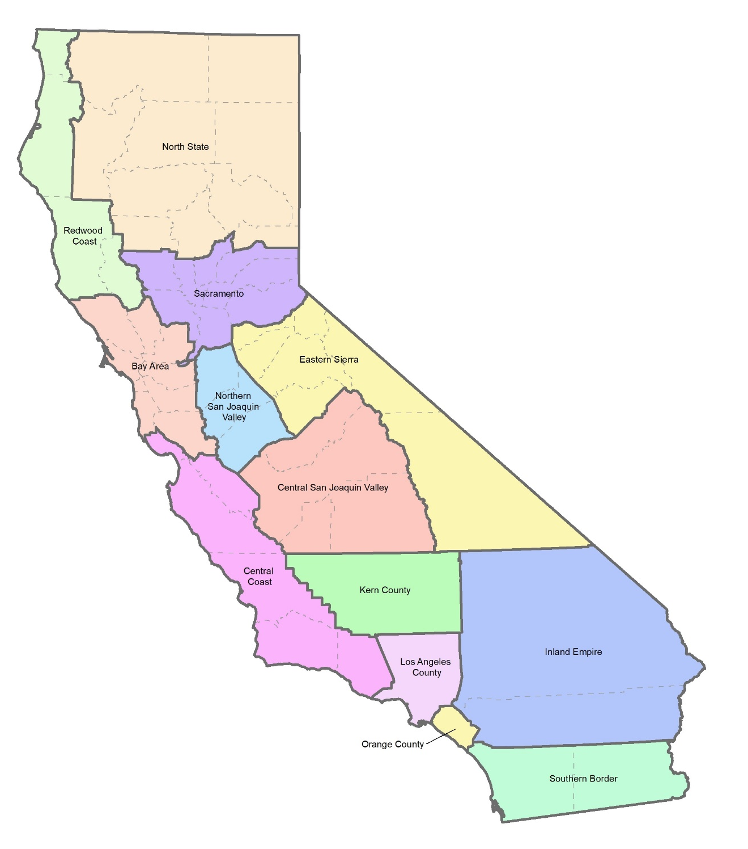

Economic Regions | Counties
Southern Border | - Imperial  - San Diego
Inland Empire | - Riverside  - San Bernardino
Los Angeles County
Orange County
Central Coast | - Monterey  - San Benito  - Santa Barbara  - Santa Cruz  - San Luis Obispo  - Ventura
Northern San Joaquin Valley | - Merced  - San Joaquin  - Stanislaus
Central San Joaquin Valley | - Fresno  - Kings  - Madera  - Tulare
Kern County
Eastern Sierra | - Alpine  - Amador  - Calaveras  - Inyo  - Mariposa  - Mono  - Tuolumne
Bay Area | - Alameda  - Contra Costa  - Marin  - Napa  - San Francisco  - San Mateo  - Santa Clara  - Solano  - Sonoma
Sacramento | - Colusa  - El Dorado  - Nevada  - Placer  - Sacramento  - Sutter  - Yolo  - Yuba
Redwood Coast | - Del Norte  - Humboldt  - Lake  - Mendocino
North State | - Butte  - Glenn  - Lassen  - Modoc  - Plumas  - Shasta  - Sierra  - Siskiyou  - Tehama  - Trinity

Frequently Asked Questions:
Question #1 - My region already has some existing economic development planning efforts. Will the CERF-funded regional planning table overtake or erase our efforts? In other words, how will subregional efforts tie into the CERF economic regions?
Answer #1 - CERF seeks to build on, not overtake existing economic development efforts. Think of these new, regional planning tables as a “team of teams.” Existing local planning efforts (e.g., Comprehensive Economic Development Strategies, High Road Training Partnerships, Recovery Task Forces, etc.) will be incorporated into the larger planning table, alongside representatives from other voices and/or corners of the region that may have not been involved in prior planning efforts. The organization that serves as the “neutral intermediary” or “convener” will help facilitate setting these new, inclusive planning tables. The momentum and activities of more localized planning efforts will be able to continue.

Question #2 - My region is large and diverse. The delineation of regions does not reflect the reality of many communities and economies, and I worry that rural, tribal, and minority communities will not be meaningfully included in the process.
Answer #2 - The aim of this program is to create meaningfully inclusive planning tables to collaborate in the design of a blueprint for a region’s recovery from COVID-19 and transition to a carbon-neutral economy. Just like a “team of teams,” representatives from various community groups throughout the CERF economic region—from urban to rural to tribal—must be at the table to provide their input, perspective, and expertise. That is what makes this program so transformational and meaningful: a community and worker-centered approach to economic development planning.
Question #3 - Industries do not fit neatly within the CERF economic regions. How do we accommodate for this in our processes?
Answer #3 - We understand that industries may exist in several regions, and/or industries may cross regional borders. The planning phase may account for this, and implementation projects can support projects that cross regional boundaries. During the planning process, you are encouraged to collaborate with any of the other economic regions, especially those who have similar industries and/or economic challenges. To the extent feasible, the state team can help support making these connections among economic regions.

Question #4 - You mentioned specific examples of local and regional economic development planning efforts that have been taking place in California. If I am located in the same region as one of these planning processes but am not already part of that effort, have we already missed the opportunity to be at the table?
Answer #4 - No, these regional tables will be new tables and there will be opportunity to engage regardless of what previous activity has occurred in your area. The CERF economic planning process is an opportunity to engage many new voices and communities who may not have previously participated in economic development efforts in your region.
Question #5 - Your memo failed to highlight the uniqueness of my county or region, and/or did not include the specific efforts that my organization is doing.
Answer #5 - We understand that each locality, county, and region is unique. Moreover, we realize there are impressive efforts happening around the state, ranging from High Road Training Partnerships to Economic Development Councils, among others. We certainly did not attempt to touch on all the unique localities and partnerships in our large and diverse state, and instead we opted for a more manageable, higher-level memo.
Question #6 - Why will regions receive the same amount for planning efforts?
Answer #6 - We are providing all regions with the same amount for planning because each region faces different types of difficulties as it relates to recovery from COVID-19, and we aim to provide resources to all parts of the state.

Question #7 - This all seems to be moving very quickly. Why?
Answer #7 - The funds are from the American Rescue Plan Act and must be encumbered by June 30, 2024 for both the planning and implementation phases. Therefore, we aim to strike a balance between providing enough time for public comments and feedback on the program, while also ensuring that each region has enough time to come together to work on planning processes.
Question #8 - I have questions about the planning phase, such as what entities are eligible to apply?
Answer #8 - We welcome your questions and feedback on the planning phase. Draft guidelines will be available for public comment in December 2021.

